

Software Requirements Specifications for

Travel Cambodia

3-Jan-2026
Version 0.1

Prepared By
“Group 9”

Change History

Date | Version | Description | Updated By
3 March 2026 | 0.1 | Initial Draft | Ea Bunleang

Document Approvals

Name | Role | Signature
Ea Bunleang | Ux/UI Designer | Bunleang
Mon Makara | Ux/UI Designer | Makara
Heng Hour | SRS Document Writer | Hour
Heng Pengly | SRS Document Writer | Pengly
Heng Sengthay | ER Diagram Designer | Sengthay

Table of Contents
1. Introduction 4
1.1 Purpose of the document 4
1.2 Scope of the project 4
1.3 Stakeholders involved 5
1.4 Overview of the Travel Cambodia platform 6
2. Overall Description 7
2.1 Product perspective 7
2.2 Product functions 8
2.3 User characteristics 9
2.4 Constraints 9
2.5 Assumptions and dependencies 10
2.6 Apportioning of requirements 11
3. Specific Requirements 11
3.1 Functional Requirements 11
3.1.1 User account management 11
3.1.2 User Review 12
3.1.3 User Itinerary Planner 12
3.2 Non-functional Requirements 14
3.2.1 Performance 14
3.2.2 Security 14
3.2.3 Reliability and Availability 15
3.2.4 Usability 15
3.2.5 Scalability 16
4.Use Cases 16
4.1 Product browsing and searching use case 16
4.2 Product ordering and checkout use case 17
4.3 User account management use case 19
4.4 Payment processing use case 19
4.5 Order tracking and status use case 19
5.Appendices 20
5.1 Glossary of terms 20
5.2 List of acronyms and abbreviations 21
5.3 References and resources 22

1. Introduction
1.1 Purpose of the document
The purpose of this document is to describe the requirements for the Travel Cambodia system. It explains what the system should do and what it should not do. It also lists the main quality needs, such as usability, security, and performance.
This document is used to help the project team and stakeholders understand the same goals. It supports planning, design, development, and testing. It also helps the team check whether the final system meets the expected features and quality.
In short, this document is the main guide for building the Travel Cambodia prototype and improving it later.
1.2 Scope of the project
Travel Cambodia is a travel platform that helps local and international tourists find places to visit in Cambodia and plan their trips. The system focuses on providing clear travel information and simple trip planning.
The first version will be a mobile-friendly/website so users can access it easily on phones and computers. A mobile app can be considered later if needed.
The system will include these main features:
- Place browsing and searching: Users can browse places by category and city, search by keyword, and view place details such as description, photos, contact info, and a map link.
- Itinerary planning: Users can create a trip plan and organize places by days (Day 1, Day 2, etc.). Users can edit the plan and add simple notes.
- User account (optional for MVP): If needed, users can register to save itineraries and view request history. For a simpler prototype, users can use the system without login and only provide phone/email when sending a request.
- User ratings and comments: Users can give ratings on places and also comment in the place they have visited. They can also send pictures that they have visited in that area as well.
- Admin Content management: Admin can add/edit/delete places, manage categories/cities.
- Super Admin Panel: Super admin can create/delete admins & users, assign roles, manage permissions and reset passwords.
The project will be built step by step, starting with the MVP features first, then improving them for the Y2S2 prototype.
Not included in this version:
- Real online payment integration
- Full personalized AI recommendations
- Large partner integrations or external booking APIs
1.3 Stakeholders involved
1.3.1 Travel Cambodia Project Owner/Management
The project owner (or project leader) guides the project direction. They provide requirements, review progress, and give feedback to make sure the system follows the project goals.
1.3.2 Content Admin/Operators
Admins manage the travel information inside the system. They add and update places, categories, and cities. They need access to the admin panel to do these tasks.
1.3.3 Tourists (Users)
Tourists are the main users. They use the system to search places, view place details, plan an itinerary and contact service providers. The system must be simple and easy for both local and foreign users.
1.3.4 Developers
Developers design, build, test, and deploy the system. They work with the project owner and admins to implement the requirements and ensure the system is stable and usable.
1.3.5 Tester
Perform quality assurance (QA) to identify bugs and issues before the launch. They verify that all features work as described in the requirements and ensure the system is stable for users.
1.3.6 Designer
Responsible for the User Interface (UI) and User Experience (UX). They create the visual layout and flow of the application to ensure it is attractive, intuitive, and easy to navigate for tourists.
1.3.7 Project manager
Oversees the project timeline, resources, and tasks. They coordinate communication between the team and stakeholders to ensure the project stays on track and is delivered on time.
1.3.8 Super Admin
- Create/Delete Admins & Users: Super Admins can add, edit, suspend, or remove any user or lower-level administrator across the entire instance.
- Assign Roles: They define and assign administrative roles, determining who can manage specific, limited areas (e.g., help desk admins).
- Manage Permissions: They control permissions, including the ability to restrict user access to sensitive information or specific applications.
- Reset Passwords: They can reset passwords for anyone in the organization, including other administrators.
1.3.9 IT Support
Give support to customers on technical/non-technical problems.
1.4 Overview of the Travel Cambodia platform
The Travel Cambodia platform is an online system that helps tourists discover places in Cambodia and plan their trips. The main goal is to make travel planning easier by putting useful information in one place. Users can search for places, view details and build an itinerary.
The Travel Cambodia platform includes these main features:
1.4.1 Place Catalog
The place catalog contains a list of travel places, such as temples, beaches, food places, hotels, and activities. Each place includes simple information like name, description, photos, city, map link, and contact details. Users can browse by category and search by keyword.
1.4.2 User Accounts (Optional for MVP)
Users may create an account to save their itineraries and view their request history. If you want a simpler prototype, users can still use the platform without an account and only provide a phone number/email when sending a request.
1.4.3 Itinerary Planner
This feature helps users plan their trip day by day. Users can create a trip and add places to Day 1, Day 2, Day 3, and so on. Users can also edit the plan and add notes (example: time, meeting point, budget).
1.4.5 User ratings and comments:
Users can give ratings on places and also comment on the place they have visited. They can also send pictures that they have visited in that area as well.
1.4.6 Admin Content Management
Admins manage the content in the system. They can add, edit, and delete places, manage categories and cities.
1.4.7 Super Admin Management
Super admin can create/edit/delete customers or admins accounts, assign roles, manage permissions and reset admin passwords.
This platform is designed to be easy to use, especially for tourists who need quick and clear travel information.

2. Overall Description

2.1 Product perspective
The Travel Cambodia will be a standalone software system that will be designed and developed on user-centric platforms that simplify travel planning, and navigation throughout Cambodia. The software system will be developed using modern web development technologies and will be hosted on a cloud platform.
2.1.1 Recommendation System
The Travel Cambodia app will make a recommendation system to provide personalized suggestions for destinations for users. This system will use user preferences and tags to highlight hidden gems and relevant experiences. – next ver
2.1.2 Traveler Interface
This interface will allow users to browse destinations, and access recommendations. It is a localization of the ecosystem connection for foreign tourists and provides an intuitive experience for local travelers.
2.1.3 Admin Interface
The admin interface will enable system administrators , and update content such as destinations. User account

2.2 Product functions
The Travel Cambodia will provide the following functions for customers:
2.2.1 Destination Browsing
Users will be able to browse destinations, hotels, local food spots, and activities through various categories. They can view detailed descriptions, images, and pricing information for each option.
2.2.2 Smart Search
Users can search using our own custom search engine, which returns the relevant results based on keyword, category, or tags.
2.2.3 Traveler Account Management (User Profile)
Users can create accounts to store personal information. They can update personal details, and manage account settings.
2.2.4 Content Management
Admins can manage destination and service information, including descriptions, images, and pricing. They can add new listings and remove outdated ones.
2.2.5 Customer Support
Admins can provide support through the app by responding to inquiries and resolving issues.
In summary, the Travel Cambodia app will offer a complete set of functions for travelers and administrators, including browsing, searching, account management, content management, and customer support.

2.3 User characteristics
Travel Cambodia is an agency app created to help the client find their travel destination and help them organize their travel plan to maximize the efficiency, including:
• Customers who are interested in browsing and planning the travel plans from Travel Cambodia. The users may have varying levels of budgets and interest to travel to different places inside Cambodia.
• The Travel Cambodia agency app is responsible for recommending, suggesting, and finding the perfect mapping, where the user checks out each place and what the user should do when they get there and customer support is provided.
• The following are some of the key user characteristics that have been considered in the design of Travel Cambodia:
• Technical Proficiency: The app is designed to be as user-friendly as possible with relevant interactive UI and straightforward steps.
• Language: The app supports English/Khmer language only.
• Security: The app will require users to create user accounts and log in to access certain features, such as travel plan and user’s profile. The app will implement security measures to protect user data and prevent unauthorized access.

2.4 Constraints
The development of Travel Cambodia is a very important project to a wide range of local users for now. The development of the app includes:
• Technology Limitations: Currently, our reach on advanced technologies to recommend to the user with relevant interests is limited.
• Time Constraints: The development of the Travel Cambodia project has a tight deadline. This will require careful planning and execution to ensure the app is completed on time.
• Budget Constraints: The development of an app is subject to a fixed budget, which will need to be carefully managed throughout the development process.
• Legal and Regulatory Constraints: The app must comply with all relevant laws and regulations, including data protection and privacy regulations.
• Performance and Scalability Constraints: The portal must be designed to handle high levels of traffic and usage and must be scalable to accommodate future growth. But for now we still need time to scale it.
• Security reasons: The app needs some security measures to protect user data and prevent anomalous access.

2.5 Assumptions and dependencies
The development of Travel Cambodia is based on our idea to solve our country's problems that are important to consider during the design and implementation process. These include:
Assumptions:
• Travel Cambodia will be developed, designed, and polished by our group development team.
• The app will be developed using the newest and most well-known technology infrastructure and technology stack.
• The app will be hosted on our server and maintained by our team.
• Our development team has the necessary skills, resources, and problem-solving skills to complete the project.
Dependencies:
• Travel Cambodia is dependent on the availability, functionality, and newest technology of our team-designed systems and infrastructure, including databases, servers, and networks.
• The app might be depending on third-party software and services, such as payment gateways and database service providers.
• The development team is dependent on timely access to resources and information, including technical documentation and design specifications.

2.6 Apportioning of requirements
The requirements for Travel Cambodia have been apportioned into different phases to enable a phased approach to development and deployment. The apportioning of requirements are based on the criticality and complexity of each requirement, as well as the dependencies between them.
The apportioning of requirements is as follows:
Phase 1: Basic our functionality
• User registration and login
• Browsing and search engine
Phase 2: Our advanced app functionality
• Travel place recommendations
• Customer reviews and ratings
• Customer service
• Social media integration
• Relevant algorithm
Phase 3: Web application development
• Design website UI for pc
• Web-specific features, such as push notifications and location-based services
The apportioning of requirements enables a gradual and phased approach to development, allowing for incremental testing and validation of features. Each phase will be delivered based on a fixed timeline and budget, and the final product will incorporate all of the required features and functionality.

3. Specific Requirements

3.1 Functional Requirements

3.1.1 User account management

- User Registration: This website allows users to register by using their email address or third party like google.
- User Login: This website allows users to log in after registration using their email and password or google.
- Forgot password: This website allows users to reset their password. The system sends OTP to their email address for security purposes.
- User profile: This website allows users to manage their profile, like changing their photo.

3.1.2 User review

- Submission: This website allows users to submit text reviews and star ratings for a location.
- Display: This website can calculate and display ratings for each location.
- Media Upload: This website allows users to attach photos to reviews.

3.1.3 Itinerary Planner
- Custom Trip Creation: Users can create a new trip by entering their destination, start date, and end date.
- Day-by-Day Scheduling: A timeline view where users can add specific activities.

3.1.4 Location Discovery and Filter
- Map Visualization: To find their destination.
- Search/Browse: Users can search, or filter by category to find the place.

3.2 Non-functional Requirements

3.2.1 Performance requirements
+ Asset Loading
- Requirement: The contents and images must occur within 1.5 seconds when the user is on the website.
+ API
- Requirement: The backend API must be able to handle at least 50 requests per second without crashing.

3.2.2 Security
+ Data Privacy & Authentication
- Detailed Requirement: Passwords must never be stored in plain text. They must be very secure and can only be accessed by the data administrator.

3.2.3 Usability
+ Mobile Responsiveness & Layout
- Requirement: The UI must adapt to other viewing methods like for mobile, tablet and computers
+ Error Feedback
- Requirement: Error messages must be user-friendly in order for the user to know what’s going on instead of giving them technical terms.

3.2.4 Reliability & Availability
+ Recoverability
- Requirement: The database must be saved and backed up automatically (every 24 hours). The system would be able to recover in 1 hour after any crashes.

3.2.5 Scalability
1. Database Scalability
- Detailed Requirement: The database tables must be properly stored in the database (e.g., indexing the Place_ID column). This ensures that searching for reviews remains fast (under 1 second) even when the database grows larger.

4. Use Cases

4.1 Place browsing and searching use case
Diagram:
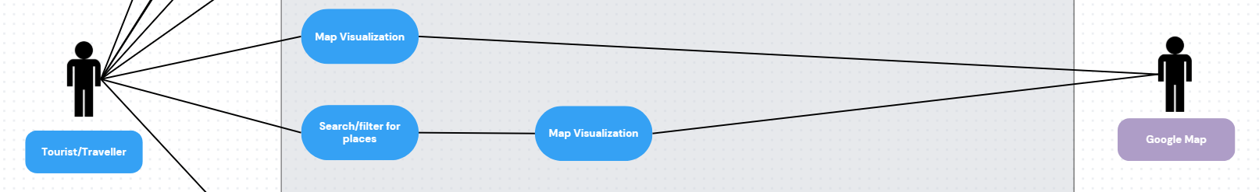
Product browsing and searching use case:
Description: This use case describes the process of browsing and searching for a travel destination or place on the Travel Cambodia platform.
Actors:
- Tourist (User): A local or international user who visits Travel Cambodia to find places to visit and plan their trip.
- System: The Travel Cambodia platform that provides destination browsing, searching, and filtering functionality.
Preconditions:
- The tourist has internet access.
- The tourist has opened the Travel Cambodia website (or app).
Post-conditions:
- The tourist can view a list of places matching their search criteria or category.
- The tourist can view details of a specific place.
- The tourist can add the place to their itinerary​Plan.
Basic Flow:
- The tourist navigates to the search bar or the "Explore" section on the Travel Cambodia platform.
- The tourist enters keywords (e.g., "Angkor Wat", "Cafe") or selects a specific Category (e.g., Temple, Beach) and City.
- The system retrieves and displays a list of places matching the search criteria.
- The tourist can filter the list of places by various parameters such as City, Category, or Rating.
- The tourist clicks on a place to view its details (Description, Photos, Map link, Contact info).
- The tourist selects "Add to Itinerary" to include the place in their trip plan (e.g., assigning it to Day 1).
Alternative Flows:
- If the tourist does not enter any keywords, the system displays a default list of places
- If no places match the search criteria, the system displays a message informing the tourist that no places were found and suggests broader keywords.
- If the tourist does not want to add the place to an itinerary immediately, they can simply navigate back to the list to browse other places.
Exceptions:
- If the system is down or experiencing technical difficulties (e.g., database connection error), the tourist will be unable to load the place list. An error message will be displayed asking the user to try again later.

4.2 Itinerary Planner
Diagram:
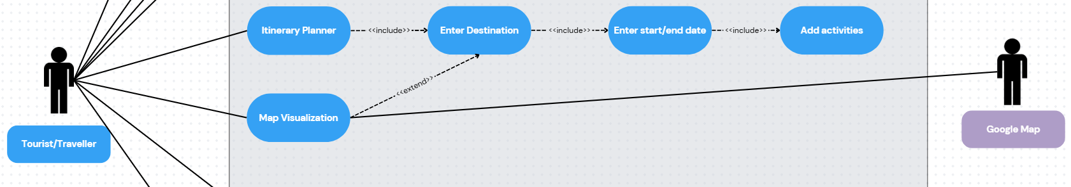
Description: This use case describes the process of creating and organizing a travel plan (itinerary) on the Travel Cambodia platform.
Actors:
- Tourist: A user who wants to organize places into a trip plan.
- System: The Travel Cambodia platform that provides the planning functionality.
Preconditions:
- The tourist has browsed and identified places they want to visit.
- (Optional) The tourist is logged in to save the itinerary permanently.
Post-conditions:
- The itinerary is saved to the user's profile (or local storage for guest users).
- The system displays the organized trip schedule by day.
Basic Flow:
- The tourist navigates to the "Itinerary Planner" section or clicks "Add to Plan" on a specific place.
- The system prompts the tourist to create a new trip (entering trip name, start date, and end date).
- The system creates a timeline (Day 1, Day 2, etc.).
- The tourist assigns selected places to specific days and times.
- The tourist adds simple notes (e.g., "Lunch here," "Bring camera") to the activities.
- The tourist clicks "Save Plan."
- The system confirms that the itinerary has been saved successfully.
Alternative Flows:
- If the tourist already has an existing trip, they can select it to add new places instead of creating a new one.
- If the tourist wants to remove a place, they can delete it from the specific day.
Exceptions:
- If the tourist is not logged in and tries to access the plan from a different device, the data will not be available (if stored locally). The system prompts the user to register to sync data.

4.3 User account management use case
Diagram:
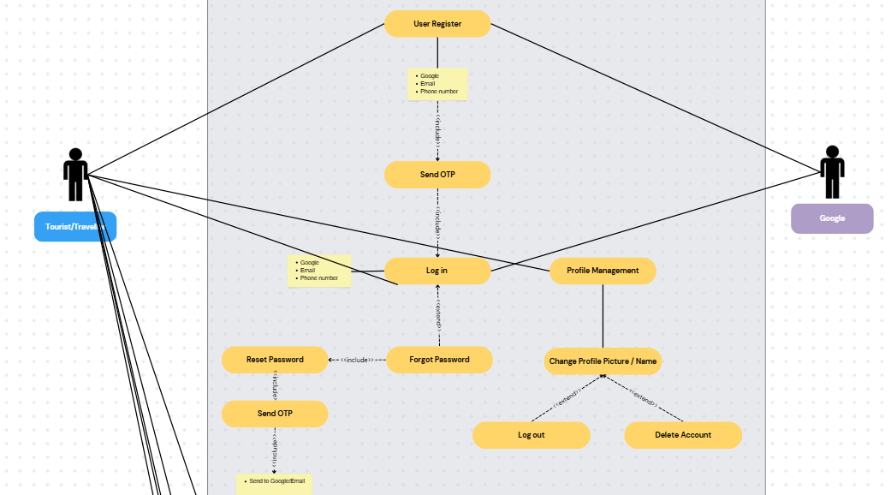
Description: This use case describes how a Tourist/Traveller registers an account via OTP verification, logs in, and manages their profile settings.
Actors:
- Tourist/Traveller: A user who wants to create and manage an account (Primary).
- System: The Travel Cambodia platform.
- Google: An external identity provider used for registration and login (Secondary).
Preconditions:
- The Tourist/Traveller has internet access.
Post-conditions:
- The Tourist/Traveller has a verified account.
- The Tourist/Traveller is logged into the system.
- Profile changes, such as name or picture updates, are saved.

Basic Flow:
- The Tourist/Traveller selects User Register and chooses a method: Google, Email, or Phone number.
- The System triggers the Send OTP process to verify the user's identity.
- Once verified, the Tourist/Traveller proceeds to Log in using their credentials or Google authentication.
- The Tourist/Traveller accesses Profile Management to view their account details.
- The Tourist/Traveller selects Change Profile Picture / Name to update their information.

Alternative / Extended Flows:
- Forgot Password: From the Log in screen, the Tourist/Traveller can select Forgot Password, which triggers Reset Password and a mandatory Send OTP verification to the user's Google/Email.
- Log out: From the Profile Picture / Name change screen, the Tourist/Traveller can choose to Log out of the system.
- Delete Account: From the Profile Picture / Name change screen, the Tourist/Traveller can choose to permanently Delete Account.

4.4 User Review
Diagram:
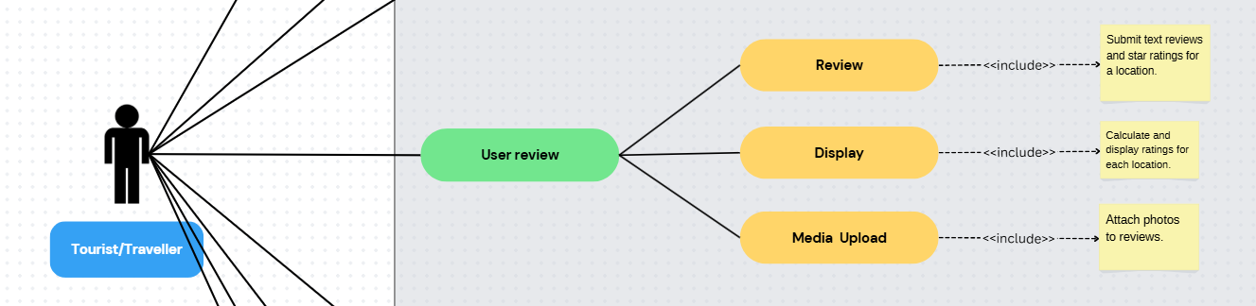
Description: This use case describes the process of a tourist leaving a review and photo for a place they visited.
Actors:
- Tourist: A user who has visited a place.
- System: The Travel Cambodia platform.
Preconditions:
- The tourist is logged in (to ensure review authenticity).
- The tourist is viewing a specific Place Detail page.
Post-conditions:
- The review and rating are visible to other users.
- The place's average rating is updated.
Basic Flow:
- The tourist navigates to the "Reviews" section of a place.
- The tourist selects a star rating (1 to 5 stars).
- The tourist writes a text comment describing their experience.
- (Optional) The tourist uploads a photo taken at the location.
- The tourist clicks "Submit."
- The system validates the content and publishes the review.
Alternative Flows:
- If the comment contains inappropriate language (if a filter is implemented), the system blocks the submission and shows a warning.

4.5 Admin Content Management Panel
Diagram:
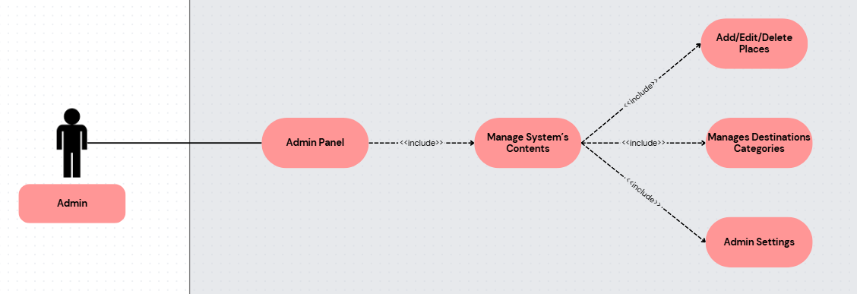
Description: This use case describes how the Admin manages the places and categories in the system.
Actors:
- Admin: A system operator responsible for content.
- System: The Travel Cambodia Admin Panel.
Preconditions:
- The Admin is logged in with administrator privileges.
Post-conditions:
- A new place is added, or an existing place is updated/deleted.
Basic Flow:
- The Admin logs into the Admin Dashboard.
- The Admin selects "Manage Places."
- The Admin clicks "Add New Place."
- The Admin enters place details: Name, Description, Category, City, Location URL, and uploads photos.
- The Admin clicks "Save."
- The system adds the new place to the database and makes it visible to tourists immediately.
Alternative Flows:
- The Admin can select "Edit" on an existing place to update information (e.g., changing opening hours).
- The Admin can select "Delete" to remove a place that is permanently closed.

4.5 Admin Content Management Panel
Diagram:
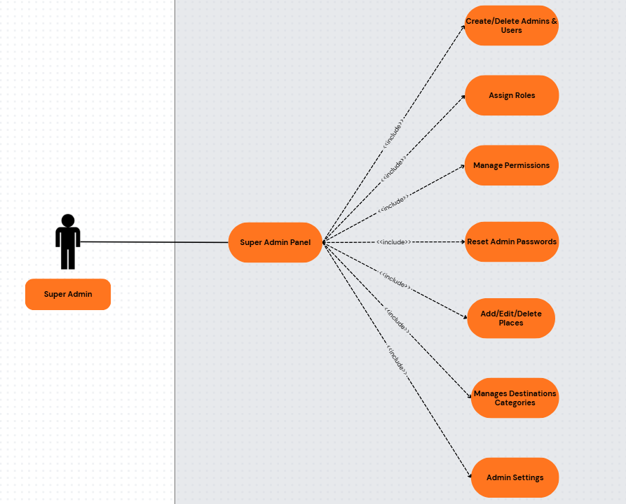
Description: This use case describes how the Super Admin manages the customers and admins accounts in the system.
Actors:
- Super Admin: A system operator responsible for managing customers and admins accounts.
- System: The Travel Cambodia Super Admin Panel.
Preconditions:
- The Super Admin is logged in with administrator privileges.
Post-conditions:
- A user/admin account has been created/edited/deleted.
Basic Flow:
- The Admin logs into the Super Admin panel.
- The Admin selects "User/Admin account"
- The Admin clicks "edit/delete"
- The Admin enters the information that they want to change or delete the account.
- The Admin can create a new account.

4.6. Get Support
Diagram:
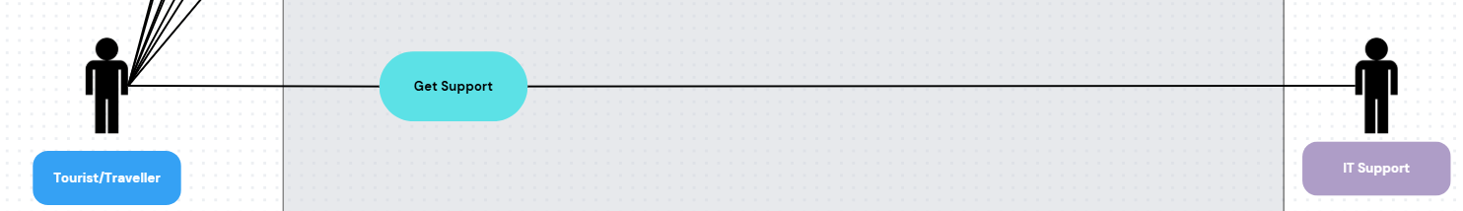
Description: This use case describes how a Tourist/Traveller requests assistance and how IT Support provides the necessary help through the system.
Actors:
- Tourist/Traveller: The primary user seeking assistance or troubleshooting.
- IT Support: The secondary actor responsible for resolving the user's issues.
- System: The Travel Cambodia Support Interface.
Preconditions:
- The Tourist/Traveller is logged into the application.
- The IT Support staff is active and available on the support dashboard.
Post-conditions:
- A support ticket/request has been created, processed, and marked as resolved.

Basic Flow:
- The Tourist/Traveller navigates to the "Support" section of the application.
- The Tourist/Traveller clicks on the "Get Support" button.
- The Tourist/Traveller enters the details of their issue or query and submits the request.
- The System notifies the IT Support team of the new request.
- The IT Support actor reviews the request and provides the necessary solution or feedback.
- The Tourist/Traveller receives the response, and the interaction is logged.

5.Appendices

5.1 Glossary of Terms (Travel‑Centric)

- Admin (Content Admin): A system operator who manages travel information inside the platform, including adding and updating places, categories, and cities.
- Itinerary: A planned trip schedule that allows users to organize places to visit by specific days (e.g., Day 1, Day 2) and add personal notes.
- One-Time Password (OTP): A temporary code sent to a user's email or phone, used for secure registration, login verification, and resetting forgotten passwords.
- Super Admin: A top-level administrator who has the authority to create, edit, or delete customer and admin accounts, assign roles, manage permissions, and reset passwords across the platform.
- Tourist: The primary user of the platform (either local or international) who uses the system to discover destinations, read reviews, and build travel plans.

5.2 List of acronyms and abbreviations
- API: Application Programming Interface
- MVP: Minimum Viable Product
- OTP: One-Time Password
- QA: Quality Assurance
- SRS: Software Requirements Specification
- UI: User Interface
- UX: User Experience

5.3 References and resources
- IEEE Recommended Practice for Software Requirements Specifications: The standard guidelines used for structuring this requirements document.
- Unified Modeling Language (UML) specification: The standard used for creating the Use Case, Class, Sequence, and State diagrams mapping out the platform's system models.
- OWASP Top Ten Project: Standard awareness document for web application security, guiding the data privacy requirements (e.g., ensuring passwords are not stored in plain text).
- Google Maps API/Documentation: Resource for integrating the Map Visualization features to help tourists find their destinations. (Note: PCI DSS was removed from this list, as real online payment integration is explicitly excluded from this version of the project.)

